**Using LINUX commands in git bash**

* LS in linux

LS is commonly used to identify the files and directories in the working directory.

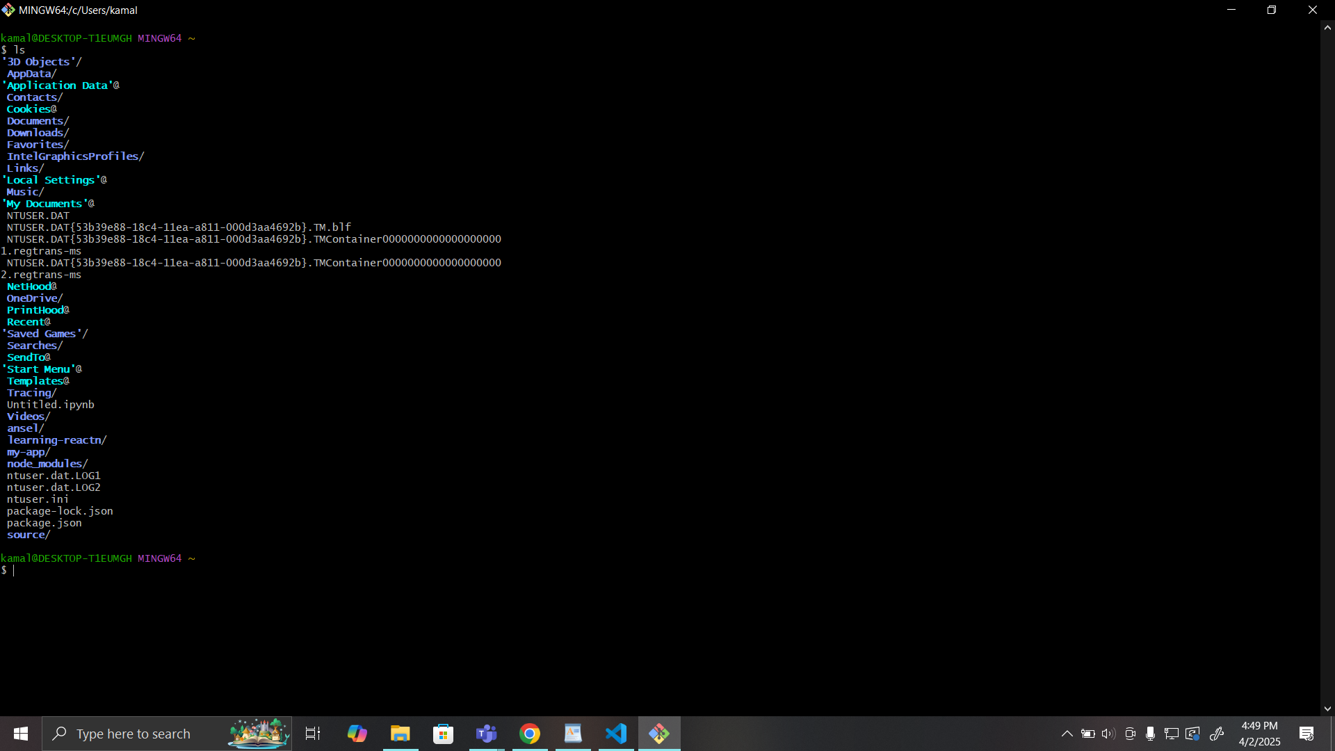

As we can see here we got all the files and directories

* PWD in linux

The [pwd command](https://www.geeksforgeeks.org/pwd-command-in-linux-with-examples/) is mostly used to print the current working directory on your terminal.

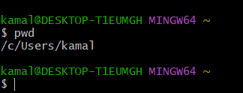

here we can see the current working directory

* mkdir command in Linux

This [mkdir command](https://www.geeksforgeeks.org/mkdir-command-in-linux-with-examples/) allows you to create fresh directories in the terminal itself. The default syntax is **mkdir <directory name>** and the new directory will be created.

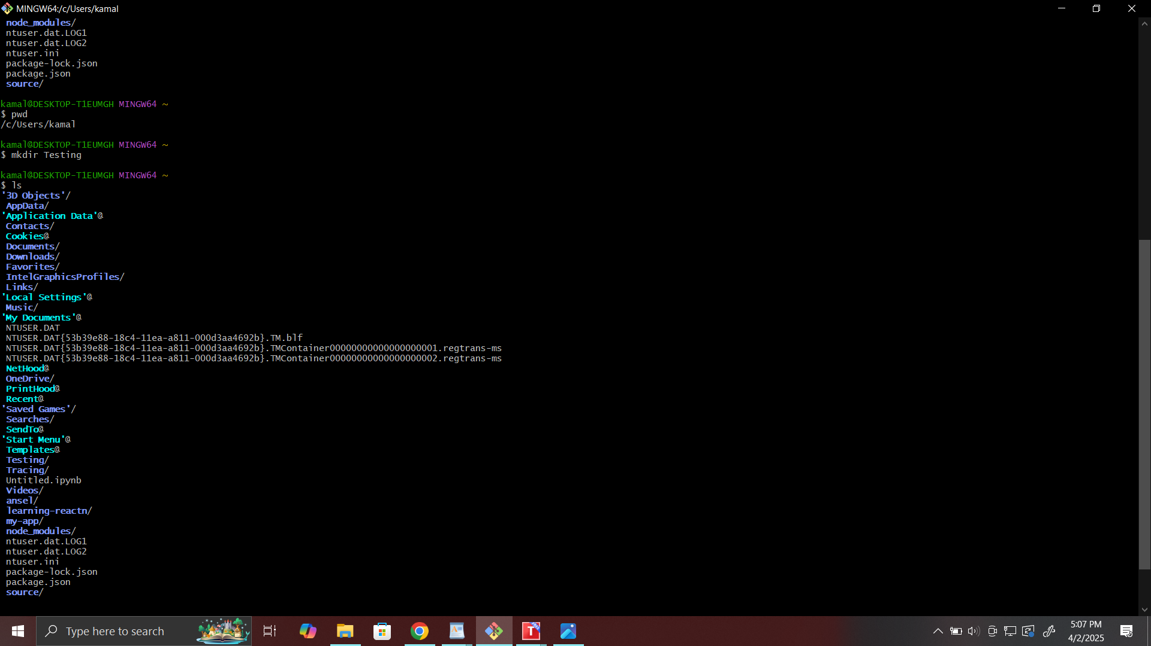

we can see here the new directory is created

* cd command in Linux

The [cd command](https://www.geeksforgeeks.org/cd-command-in-linux-with-examples/) is used to navigate between directories. It requires either the full path or the directory name, depending on your current working directory.

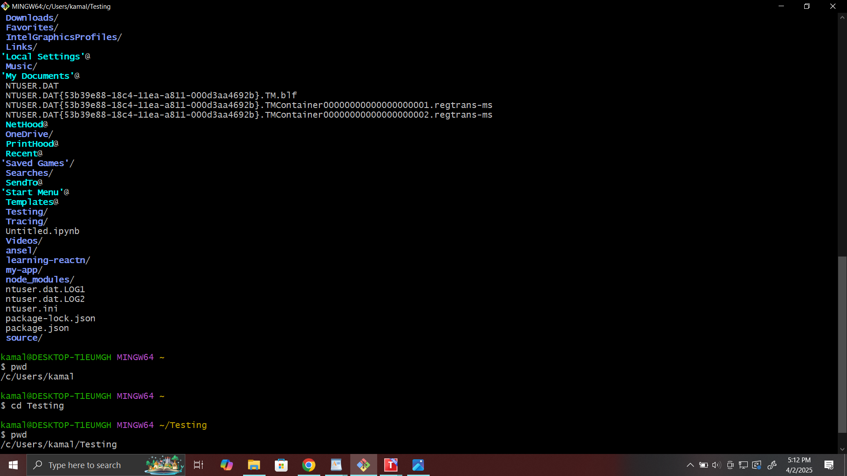

* rmdir command in Linux

The [rmdir command](https://www.geeksforgeeks.org/rmdir-command-in-linux-with-examples/) is used to delete permanently an empty directory.

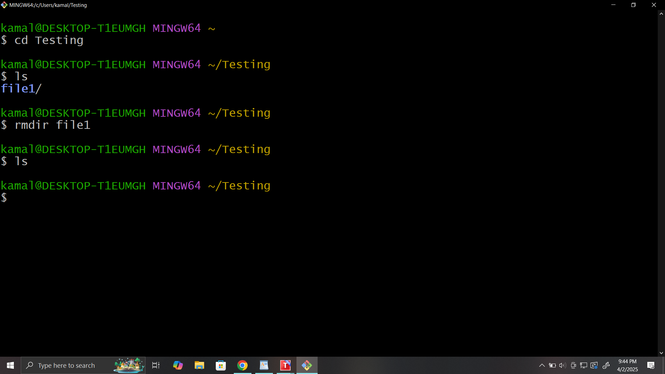

we can see that file1 directory is deleted

* cp command in Linux

The [cp command](https://www.geeksforgeeks.org/cp-command-linux-examples/)of Linux is equivalent to copy-paste and cut-paste in Windows.

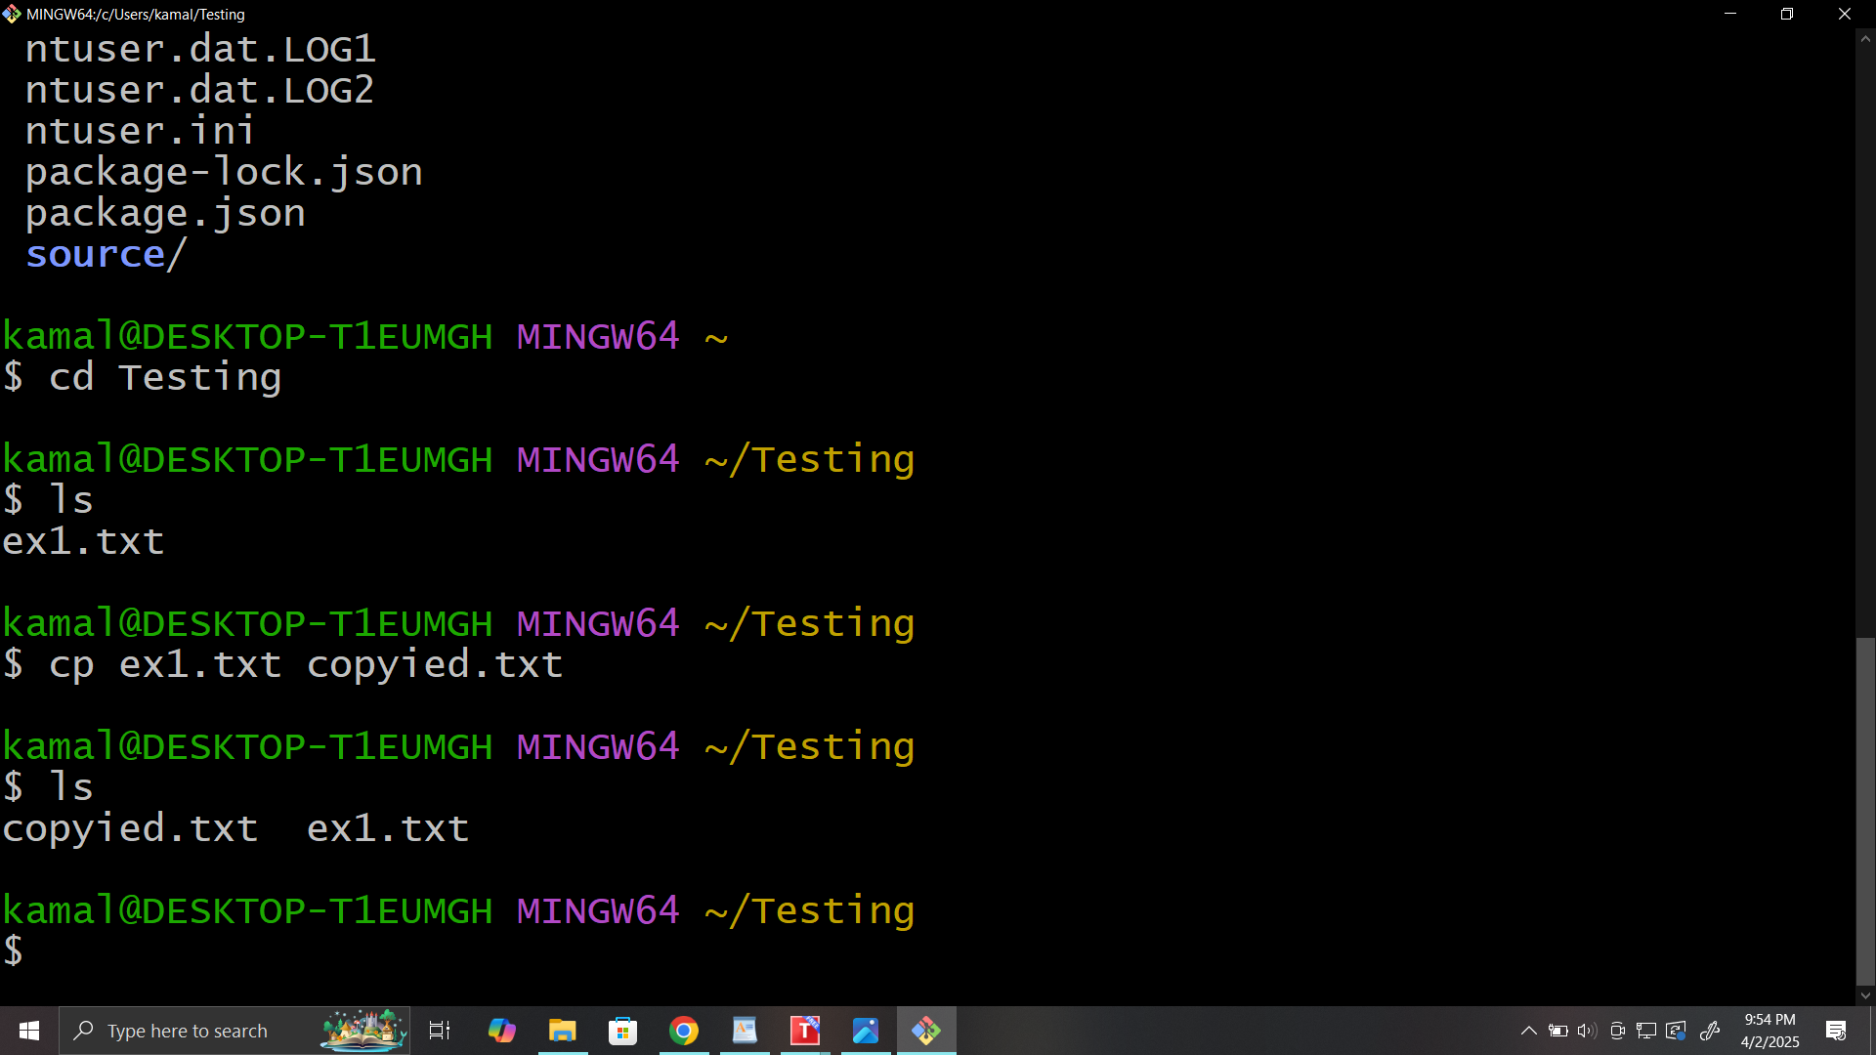

* mv command in Linux

The mv command is generally used for renaming the files in Linux.

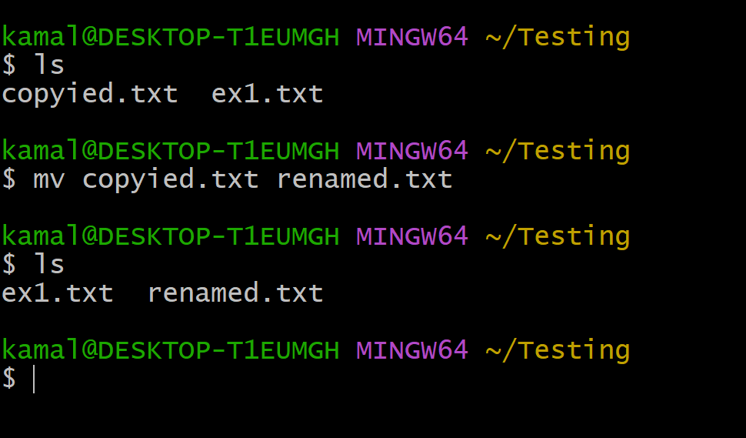

* rm command in Linux

[**rm command**](https://www.geeksforgeeks.org/rm-command-linux-examples/) in Linux is generally used to delete the files created in the directory.

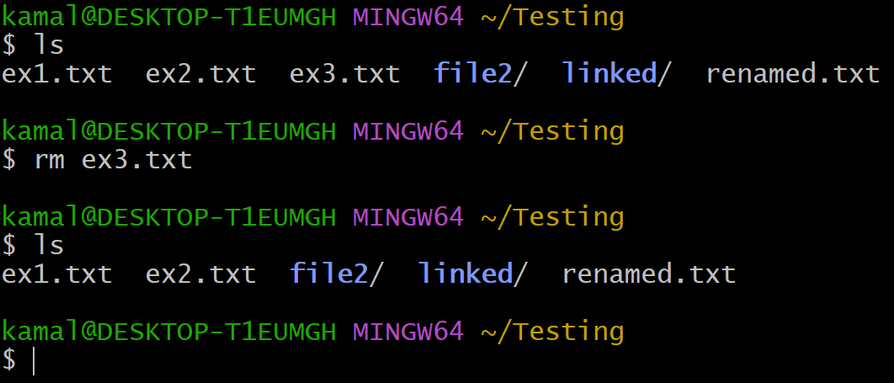

* uname command in Linux

The [uname command](https://www.geeksforgeeks.org/uname-command-in-linux-with-examples/) is used to check the complete OS information of the system.

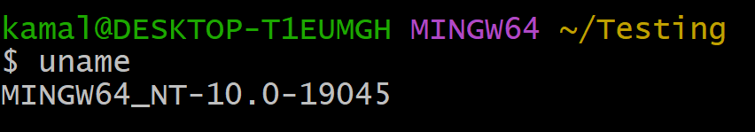

* touch command in Linux

The [touch command](https://www.geeksforgeeks.org/touch-command-in-linux-with-examples/) creates an empty file when put in the terminal in this format as touch **<file name>**

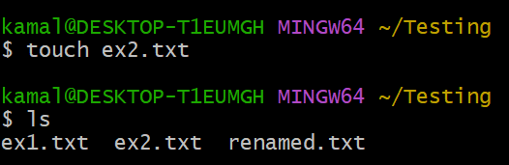

* cat command in Linux

The [cat command](https://www.geeksforgeeks.org/cat-command-in-linux-with-examples/) is the simplest command to use when you want to see the contents of a particular file.

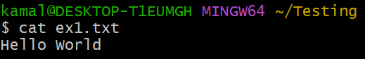

* clear command in Linux

The [clear command](https://www.geeksforgeeks.org/clear-command-in-linux-with-examples/) is a standard command to clear the terminal screen.

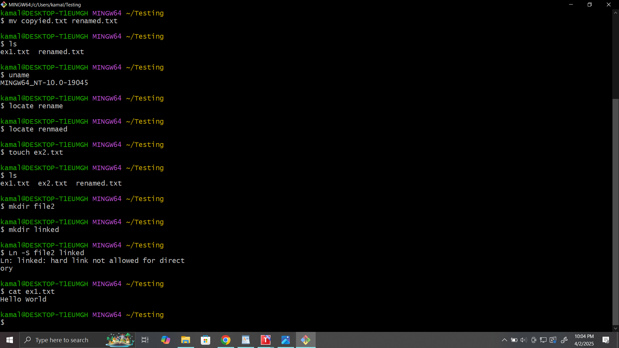

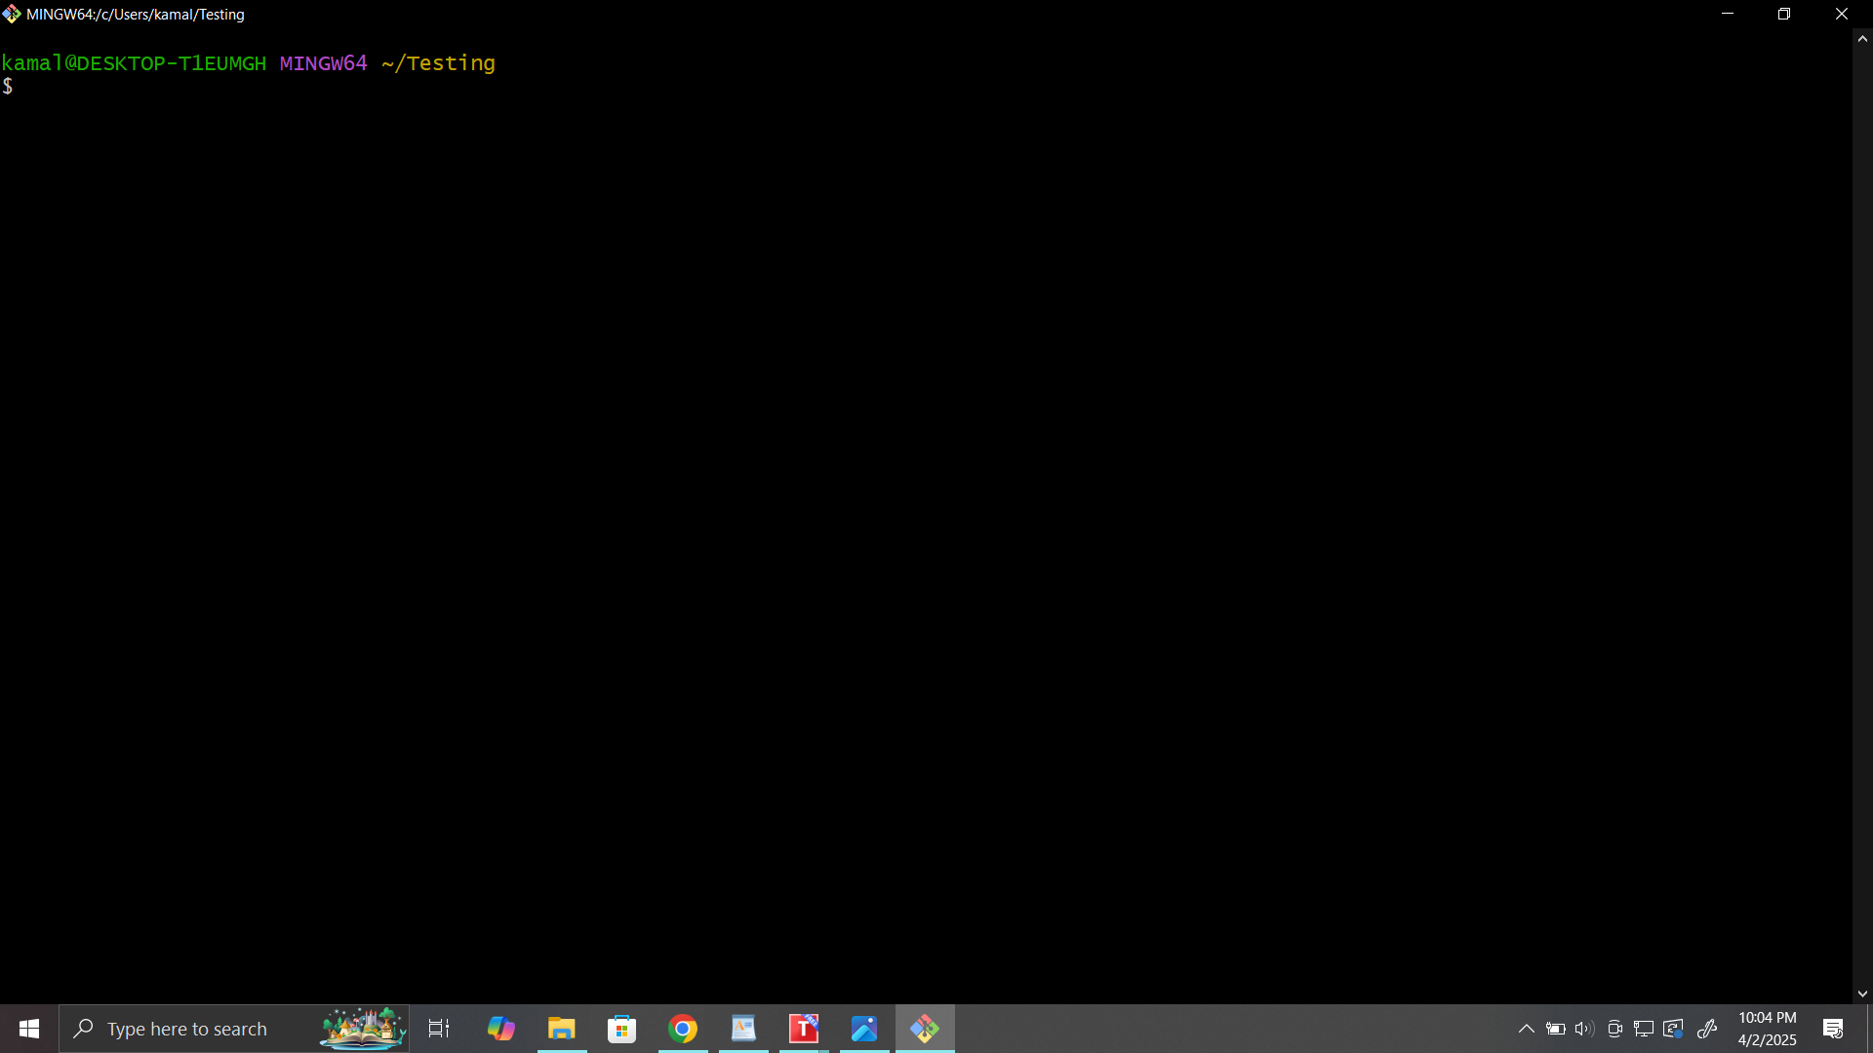

* ps command in Linux

[ps command](https://www.geeksforgeeks.org/ps-command-in-linux-with-examples/) in Linux is used to check the active processes in the terminal.

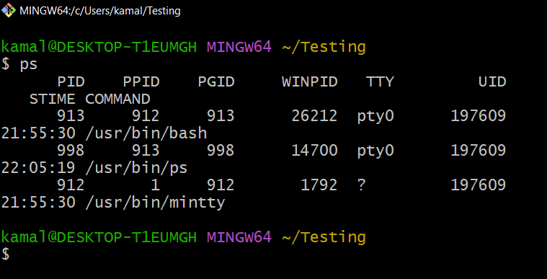

* grep command in Linux

The [grep command](https://www.geeksforgeeks.org/grep-command-in-unixlinux/) is used to find a specific string in a series of outputs.

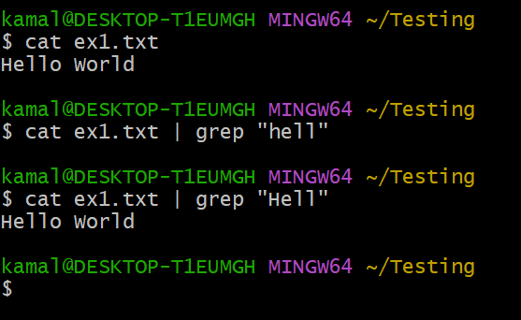

* echo command in Linux

[echo command](https://www.geeksforgeeks.org/echo-command-in-linux-with-examples/) in Linux is specially used to print something in the terminal

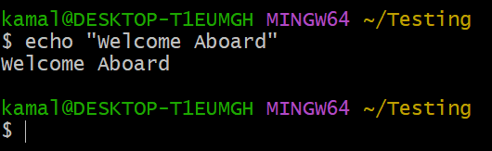

* whoami command in Linux

The [whoami command](https://www.geeksforgeeks.org/whoami-command-linux-example/) provides basic information that is extremely useful when working on multiple systems.

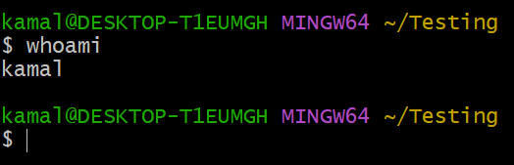

* sort command in Linux

The sort command is used generally to sort the output of the file.

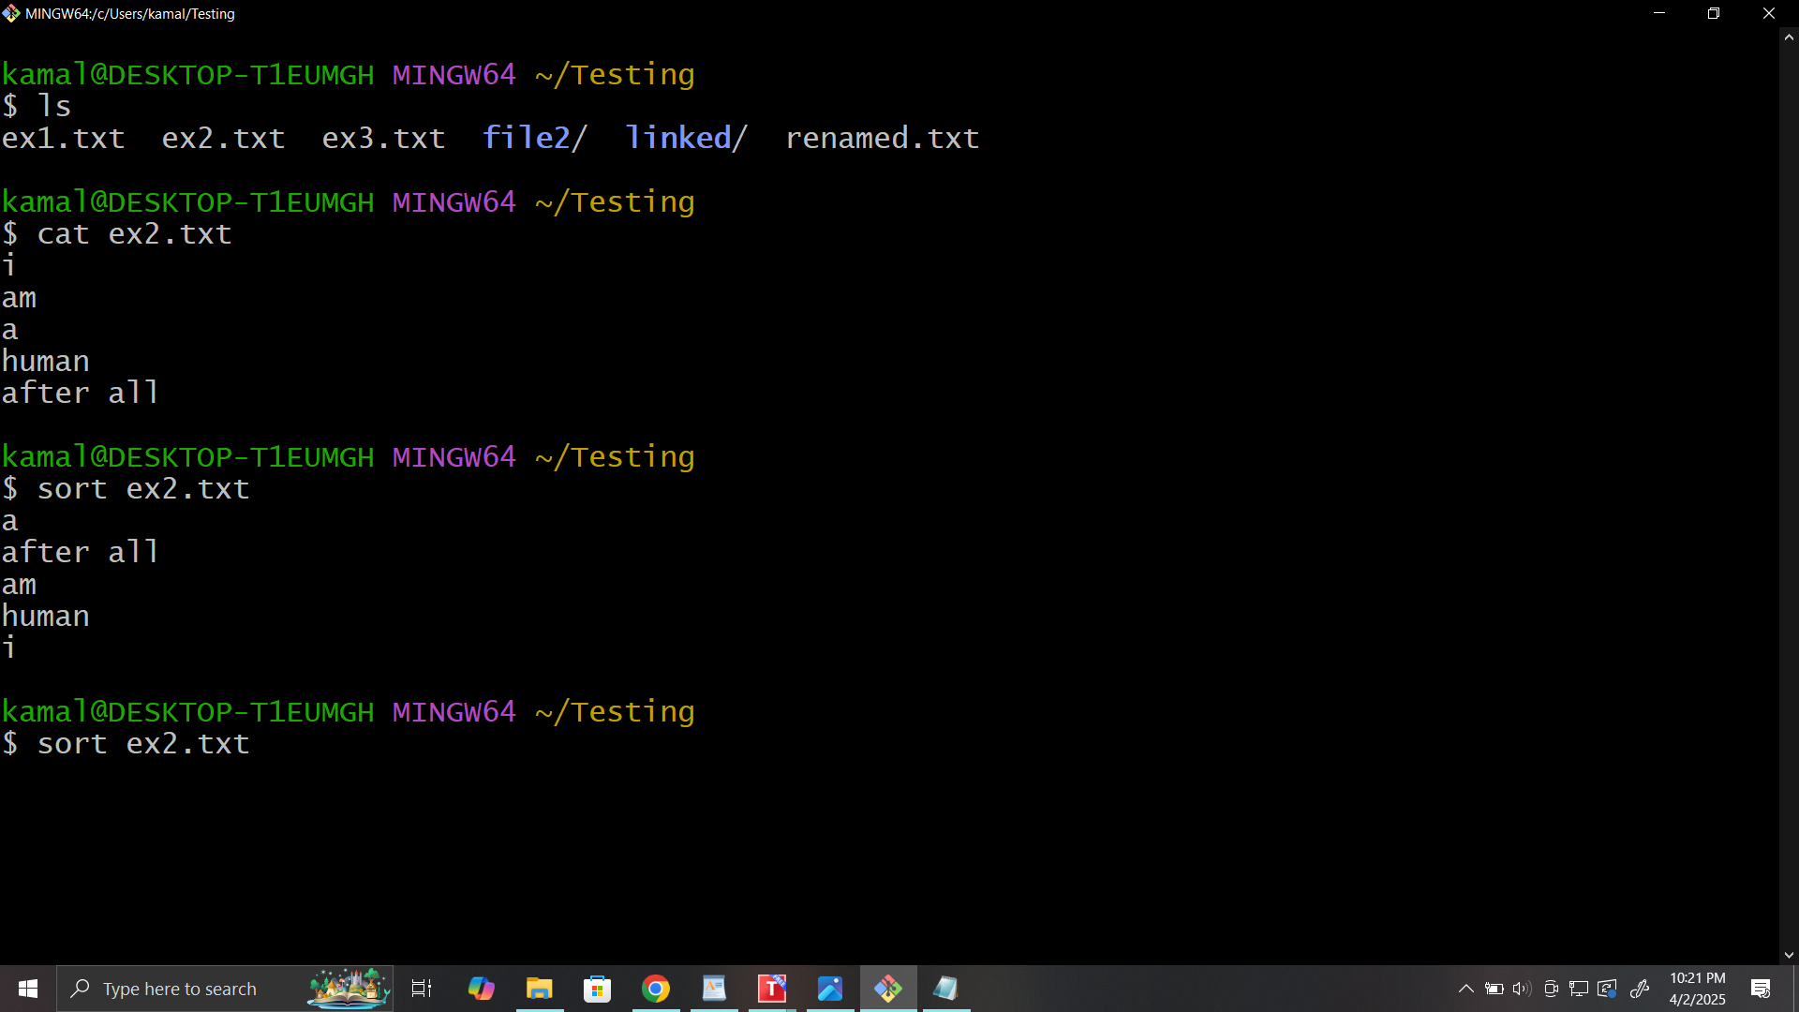

* df command in Linux

[df command](https://www.geeksforgeeks.org/df-command-linux-examples/) in Linux gets the details of the file system.

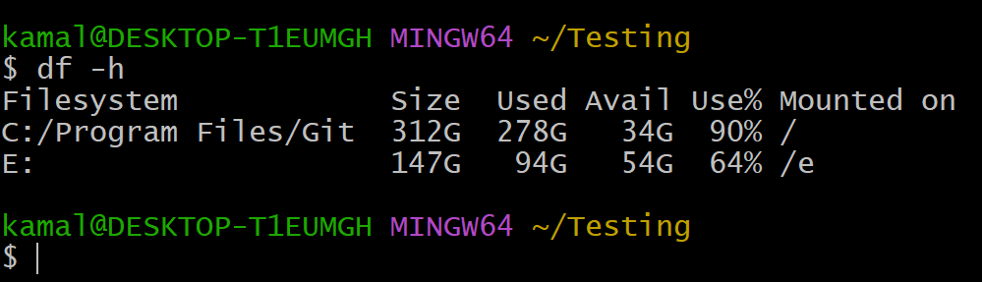

we have used **df -h** as simply typing **df**will return the output in bytes which is not readable, so we add **-h**to make the outputs more readable and understandable.

* wc command in Linux

[wc command](https://www.geeksforgeeks.org/wc-command-linux-examples/) in Linux indicates the number of words, characters, lines, etc using a set of options.

* wc -w shows the number of words
* wc -l shows the number of lines
* wc -m shows the number of characters present in a file

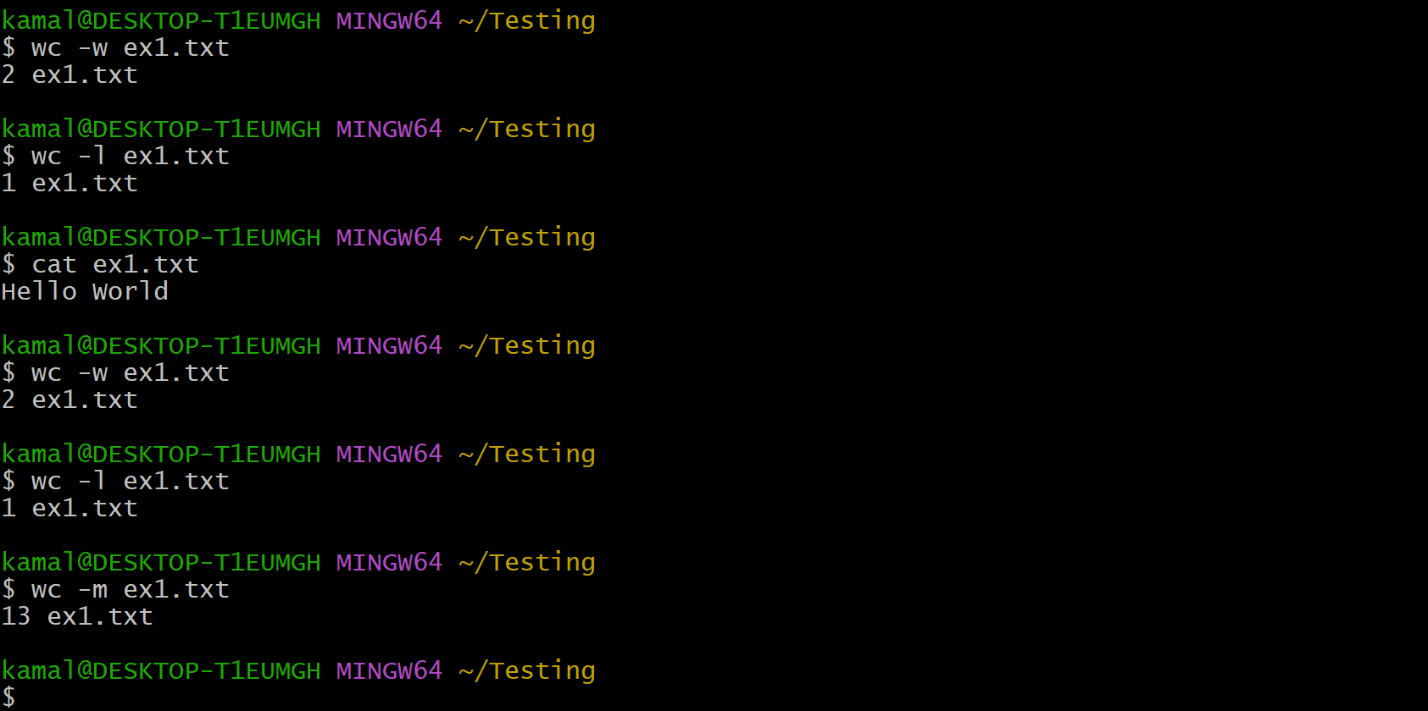

To add text inside a file we use

echo -e “some text” > filename.txt

